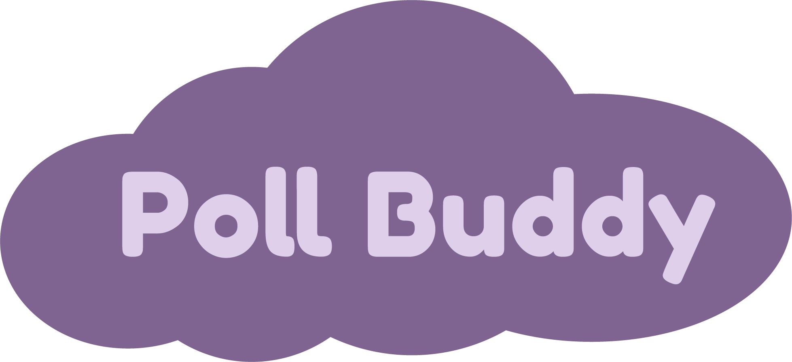

**Introduction:**

* Many professors use iClickers to ask questions or polls to their students.
* However, iClickers are expensive, bulky, outdated, easy to forget, difficult to integrate with other programs, and only professors can track answers.
* Therefore, we decided to create a website that has similar, yet improved functionality of iClickers, called **Poll Buddy**.
* Poll Buddy is a website that professors can use to interact with students during class. Professors will log in to their Poll Buddy account and will be able to create questions. Students will be able to log in to their accounts where they will be able to see the answer options and will be able to get Poll Buddy points for answering them. Both professors and students will be able to see question results and other statistics. Students will be able to view their Poll Buddy points at any time.

**Languages:** *Frontend*: HTML, CSS, JavaScript, React

*Backend*: NodeJS, MongoDB, Express, Docker

**Current Status:**

* Most frontend pages have been designed and are visually implemented in code.
* The site’s backend, responsible for handling tasks like application logic and database interactions, has a large portion of functionality complete.
* There is still a fair bit of work to do on the frontend (further visual fixes, backend integration) before Poll Buddy can enter trials for deployment and in-classroom use.

**Development Milestones:**

* By the middle of the 2020 Fall Semester, the team aims to have evolved Poll Buddy to a state where it can begin RCOS trials.
* The development milestones outlined below detail some of the steps to be taken to reach this state. The project will still need to be worked on in future semesters to refine and tailor it to the needs and feedback from students and professors.
* End of September:
  + Proposal
  + Get everyone up to speed on the repo, tools, etc.
  + RPI CAS login integration
  + Continued work on client-server communication and page functionality
* End of October:
  + Continued work on client-server communication and page functionality
  + Assumed backend bugfixes during integration
  + Code and page cleanups
  + Docker prod/dev images
  + Tests beginning
* End of November:
  + Logging/reporting work
  + Cleanup of old resources
  + Bug fixes
  + Continued testing
* End of December/Semester:
  + Further testing and fixes
  + ~~Take over~~ Change the world!

**Team Members:**

Poll Buddy **Hunter Harris** [**harrih3@rpi.edu**](mailto:harrih3@rpi.edu) **(PM)**

Poll Buddy **Neha Deshpande** [**deshpn2@rpi.edu**](mailto:deshpn2@rpi.edu)

Poll Buddy **Annie Shi** [**shia@rpi.edu**](mailto:shia@rpi.edu)

Poll Buddy **Sam Schantz** [**schans2@rpi.edu**](mailto:schans2@rpi.edu)

Poll Buddy **Enzhe Lu** [**lue3@rpi.edu**](mailto:lue3@rpi.edu)

Poll Buddy **Yao Dong** [**dongy11@rpi.edu**](mailto:dongy11@rpi.edu)

Poll Buddy **Samuel Mei** [**meis@rpi.edu**](mailto:meis@rpi.edu)

Poll Buddy **Alexia Leong** [**leonga2@rpi.edu**](mailto:leonga2@rpi.edu)

Poll Buddy **Maria Khodak** [**khodam2@rpi.edu**](mailto:khodam2@rpi.edu)

Poll Buddy **Tyler Machado** [**machat@rpi.edu**](mailto:machat@rpi.edu)

Poll Buddy **Ethan Tuttle** [**tuttle2@rpi.edu**](mailto:tuttle2@rpi.edu)

Poll Buddy **Aidan Lane** [**lanea3@rpi.edu**](mailto:lanea3@rpi.edu)

Poll Buddy **Jody Sunray** [**sunraj@rpi.edu**](mailto:sunraj@rpi.edu)

Poll Buddy **Nicholas Bezanis** [**bezann@rpi.edu**](mailto:bezann@rpi.edu)